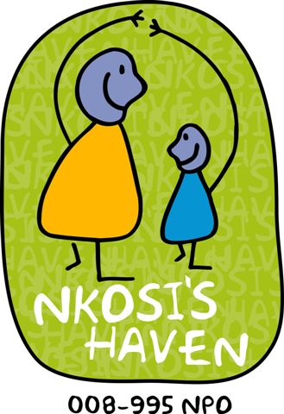
Nkosi’s Haven
VOLUNTEER APPLICATION FORM
34 Vereeniging Service Road, Alan Manor
P.O. Box 403, Melville. 2109
Tel: +27 11 942 5580/1/3/4 Fax: + 27 11 941 1408

Full Names ...........……………………………………………………..................

Residential Address ……………………………………………...................

……………………………………………………..........

Code ………………........

Country/State …………………………………………….................…………………..

Passport/Identity
Number: ..........................................................................................................

Age ..............................................................

Date of Birth .............................................................

Gender .............................................................

Contact e-mail ………………...………….....……………………………..................

Contact
Telephone Number: …….............................……………………..................................

Cell: ....……………............................................................................…

Police Clearance for Finger Prints:

Yes / No – If yes kindly attach a copy to this document.

Languages:

English | Afrikaans | Zulu | Sotho | Tswana | Venda | Xhosa | Pedi

Other: ……………………………………………………………………………………….

Categories interested in:

General repairs & maintenance work | Relieving with general household chores. | Transportation & hospital visits. | Fundraising & products sourcing (sponsorship) | Marketing of the project (Nkosi’s Haven).
Medical:  - Doctor.  - Nurse.  - Palliative Care. | Tutoring and home work monitoring:  - English.  - Afrikaans.  - Maths.  - Science.  - Economics.  - Life Skills.  - Accountancy.  - English (grammar & spelling

Other ………………………………………………………………..…………………………...

How long will you be involved (offering your service) with us?

Weeks | Months

Kindly inform us of your arrival and departure dates.

Arrival Date | Departure Date

Do you have any formal training in your chosen categories Yes / No.

Please give a brief description on your qualifications, if necessary attached a 2 page resume or CV.

- ………………………………………………………………………………………………

- ………………………………………………………………………………………………

- ………………………………………………………………………………………………

Are you aware that Nkosi’s Haven is a charity organisation and your association with it is voluntary.

Yes / No.

During your involvement with Nkosi’s Haven, if Nkosi’s Haven is not in the position to offer accommodation will you be able to arrange your own accommodation and transportation?
Yes / No.

What is your level of knowledge regarding HIV and AIDS?

………………………………………………………………………………………..……………

………………………………………………………………………..…………………………

Please briefly tell us about yourself.

............................................................................................................................................

............................................................................................................................................

............................................................................................................................................

............................................................................................................................................

............................................................................................................................................

............................................................................................................................................

............................................................................................................................................

Do you have any dietary requirements or are you allergic to any thing?.

As a volunteer, you bring a lot of value to the lives of our mothers and children. It may not feel or seem like you are doing a lot, but be assured that every little bit counts a great deal – more than you would ever imagine.
Consistency, commitment and dedication are qualities that we are looking for in our volunteers. You can volunteer as long as you like, our programme is flexible and there is no duration period.

_________________________________________________________________
Signature Date

Kindly email your application back to: volunteer@nkosishaven.org

Nkosi’s Haven Volunteer/ Foster Parenting
Guidelines

We sincerely appreciate each and every student and adult who kindly donates time, skills and effort to the various children of this organization.

Although many of our children live at the Haven with their mothers, we also have many children who have been orphaned due to HIV/AIDS, and some children who are HIV+.

Some of our children have had a history of deprivation and neglect prior to arriving and many have has issues of loss and bereavement to work through.

Our philosophy at the Haven is that EVERY child is special and loved.

Please bear in mind that not all the children are fortunate enough to have a ‘special’ person who visits, takes them for weekend visits or buys them treats.

With this in mind, and to assist us with issues that have manifested at the Haven, please take the following into consideration:

- Weekend visits away from the Haven should be every alternate weekend only. Not only do the children have chores and responsibilities over weekends but the children who do not get invited out tend to feel lost and forlorn if their friends are away every weekend.

- Gifts/clothes/treats: please restrict these to the minimum or discuss your ideas with our Resident Manager. It is difficult for children (particularly our orphans) to manage conflicting emotions when some children receive gifts and others are not as fortunate.

- Requests from our children: although we strive to teach our children certain values and norms, we are aware that children tend to make unreasonable demands for clothes, toys extra visits and the like. Please do not indulge in their requests. Special items must please only be purchased for a birthday or Christmas. We feel that things like cell phones are just not acceptable gifts, open to ‘in house’ theft etc. which occurs in homes.

- Commitment to a child: please, where possible, do not disappoint a child by changing an arrangement at the last minute. Like all children, ours are vulnerable to hurt and despair when adults don’t stick to their word.

- Suggestions/Comments: please feel free to make any suggestions which you feel will help in adding value to the children, be it recreationally or academically.

